EXPLORING GENDER INCLUSION IN SOLOPRENEURSHIP: AN EMPIRICAL STUDY AMONG LAW STUDENTS
Vaishnavi Agarwal
[ Maharashtra National Law University, Nagpur]

Abstract
Solopreneurship has revolutionized modern work culture as it enables individuals to create their own ventures with the help of technologies and innovations in the digital space. This paper looks into the issue of gender inclusivity in solopreneurship among law students. The purpose of the study is to assess awareness of solopreneurship and its gender-based barriers as well as the role of legal education and digital technology in creating equal opportunities for entrepreneurs.
This is an empirical study that uses structured questionnaires collected among law students from various courses of study and universities. The research is based on participants' opinions about equality, social and financial barriers to becoming an entrepreneur, gender stereotypes, digital access, and impact of artificial intelligence tools on solopreneurship. Research results suggest that although solopreneurship is seen as an equal, flexible career choice, there are still many obstacles connected to gender bias, lack of mentoring, inequality in networking opportunities, and stereotypes that hinder inclusive solopreneurship.
Legal education, digital awareness, and institutional support have proven to be important in creating opportunities and ecosystems that allow gender inclusivity among solopreneurs. Overall, this research proves that increased attention to the issues of gender inclusivity and digital accessibility may help in accessible and sustainable for solopreneurs in evolving digital economy.
Keywords: Solopreneurship, Gender Diversity, Inclusion, Digital Entrepreneurship, Law Students, Inclusive Entrepreneurship, Gender Equality, AI and Technology, Entrepreneurial Ecosystem, Digital Economy.
1.1 Introduction
The rise of the digital economy and technological innovation has changed traditional employment and entrepreneurship. One notable change is solopreneurship, a quickly growing model of independent work. In this model, individuals set up, manage, and run businesses without permanent employees. Solopreneurship focuses on autonomy, flexibility, digital access, and self-driven growth. Social media, artificial intelligence, e-commerce, and online networking have helped people pursue independent business ventures in various sectors.
Recently, solopreneurship has attracted attention from young professionals and students because it has low entry barriers and a flexible work structure. This model has become especially relevant in the post-pandemic era. Remote work and digital platforms have opened doors for freelancers, consultants, content creators, and independent service providers. For law students and future legal professionals, solopreneurship offers new opportunities in areas like legal consultancy, legal content creation, online dispute resolution, and independent legal services.
Even with its potential to make entrepreneurship more accessible, concerns about gender diversity and inclusion still exist in solopreneur ecosystems. Structural inequalities, social stereotypes, unequal access to funding, limited mentoring, and digital gaps can affect participation and success in entrepreneurial spaces. Women and people from marginalized communities often face extra hurdles in gaining visibility, credibility, and professional networks in independent business settings. While digital platforms have created more accessible entrepreneurial opportunities, gender-based barriers remain a pressing issue that needs attention from academics and policymakers.
The idea of inclusive entrepreneurship stresses the importance of providing equal opportunities for everyone, regardless of gender, identity, or social background. Supporting diversity and inclusion in solopreneurship is crucial not just for economic growth but also for encouraging innovation, creativity, and social equity. In this context, the views of law students are particularly significant. They are the future professionals who could shape legal, social, and entrepreneurial systems.
This study aims to explore law students' perceptions of gender diversity and inclusion in solopreneurship. Through a survey-based approach, the research will analyse awareness of solopreneurship, identify perceived gender-based obstacles, and assess the role of legal education and technology in promoting inclusive entrepreneurial opportunities. The study also contributes to the broader conversation on inclusive entrepreneurship in the changing digital economy.

2.1 Review of Literature
According to a cross-sectional study conducted among Greek undergraduate information technology students based on the Theory of Planned Behaviour, significant gender-related differences exist in entrepreneurial attitudes and intentions. The study found that affective attitude and perceived self-efficacy were the strongest predictors of entrepreneurial intention, emphasizing the importance of emotional and psychological factors in entrepreneurship. The research further revealed that the relationship between entrepreneurial commitment and actual entrepreneurial action was stronger among men than women, suggesting that gender may influence the transition from entrepreneurial intention to entrepreneurial behaviour. The study highlights the continued relevance of gender dynamics in shaping entrepreneurial participation and decision-making processes. (Vamvaka et al., 2020)
Another important study examined the relationship between entrepreneurship education, entrepreneurial intention, and gender differences among students. Drawing upon the theories of human capital and socially learned stereotypes, the study analysed how entrepreneurship education influences entrepreneurial intention, alertness, and risk-taking skills. The findings revealed that students participating in entrepreneurship education programs demonstrated higher entrepreneurial intention compared to non-participating students.
However, the study also found that entrepreneurship education did not benefit all students equally. Women students were less likely to report strong entrepreneurial intention, although women possessing entrepreneurial alertness skills showed comparatively higher levels of intention than non-participating women students. Furthermore, while male students associated risk-taking skills with stronger entrepreneurial intention, women entrepreneurship education students reporting risk perception skills demonstrated comparatively lower entrepreneurial intention. The study highlights that gender differences continue to influence entrepreneurial motivation and participation despite educational support and skill development initiatives. These findings are relevant to the present study as they demonstrate how gender perceptions and psychological factors affect entrepreneurial engagement among students. (Westhead & Solesvik, 2016)
Entrepreneurship education has increasingly been recognized as an important factor influencing entrepreneurial intention among students, particularly in rapidly evolving labour markets. A study conducted in China examined the impact of entrepreneurship education on students’ entrepreneurial intention and entrepreneurial decision-making self-efficacy. The findings revealed that students who received higher levels of entrepreneurship education demonstrated stronger entrepreneurial intention and greater confidence in entrepreneurial decision-making.
The study further identified entrepreneurial self-efficacy as a significant mediating factor between entrepreneurship education and entrepreneurial intention, suggesting that educational exposure strengthens entrepreneurial confidence and motivation. Additionally, the research highlighted that entrepreneurship-related courses had a stronger influence on entrepreneurial intention than practical entrepreneurial activities within the Chinese context. The study emphasizes the important role educational institutions play in fostering entrepreneurial skills, awareness, and confidence among students. These findings are relevant to the present study as they demonstrate how educational environments can influence entrepreneurial aspirations and inclusive participation in emerging entrepreneurial ecosystems, including solopreneurship. (Shinnar et al., 2018)
Entrepreneurship education has been widely recognized as an important mechanism for promoting entrepreneurial intention among university students and supporting economic development. A study conducted among Chinese college students examined the impact of entrepreneurship education on entrepreneurial intention across different demographic groups, including gender, household registration, institutional type, and economic background. The findings revealed that entrepreneurship education positively influenced students’ entrepreneurial intention overall. Significantly, the study found that entrepreneurship education had a stronger positive effect on women students’ entrepreneurial intention, thereby contributing to the reduction of gender disparities in entrepreneurship. However, the research also identified inequalities in the benefits derived from entrepreneurship education. Urban students, students from private institutions, and economically advantaged students experienced comparatively greater improvement in entrepreneurial intention than rural and economically disadvantaged students. The study emphasized that unequal access to entrepreneurial resources and opportunities may reinforce existing social and economic inequalities. These findings highlight the importance of inclusive and accessible entrepreneurship education in promoting equal entrepreneurial participation and reducing gender-based barriers. The study is relevant to the present research as it demonstrates how educational support and social conditions influence entrepreneurial aspirations among students. (Xu et al., 2023)
Entrepreneurship education programs and workshops have also been identified as influential factors in shaping entrepreneurial intention among students. A study examining participants of an entrepreneurship education workshop series explored the impact of social and psychological factors on entrepreneurial intention. The findings revealed that entrepreneurial disposition and participation in entrepreneurship workshops significantly influenced students’ interest in entrepreneurship. However, factors such as exposure to entrepreneurial role models and family support did not show a significant impact on entrepreneurial intention. Interestingly, unlike several earlier studies emphasizing gender differences in entrepreneurship, this research found no significant difference between men and women regarding entrepreneurial interest. The study further highlighted positive participant perceptions regarding the effectiveness of entrepreneurship programs and their contribution to venture development. These findings suggest that entrepreneurship education and skill-oriented initiatives can play an important role in encouraging entrepreneurial aspirations while potentially reducing traditional gender disparities in entrepreneurial participation. The study is relevant to the present research as it demonstrates how educational exposure and psychological readiness influence inclusive entrepreneurial engagement among students. (Pruett, 2012)

2.1.1 Research Gap
Existing research on entrepreneurship and entrepreneurial intention has looked closely at how entrepreneurship education, psychological factors, self-efficacy, and gender affect students' participation in entrepreneurial activities. Many studies show that entrepreneurship education boosts entrepreneurial intention and confidence. Other research highlights that gender differences still impact motivation, decision-making, and the shift from intention to actual entrepreneurial behaviour. Studies have also examined how social stereotypes, emotional factors, risk perception, and institutional support influence entrepreneurial engagement.
However, even with the growing interest in entrepreneurship and gender inclusion, there is limited research specifically focusing on solopreneurship as a separate and emerging form of entrepreneurship in the digital economy. Most studies concentrate on general entrepreneurship, startup ecosystems, or business management students, while there is relatively little focus on how law students view solopreneurship and inclusive entrepreneurial opportunities. Additionally, there is not enough empirical research on how gender diversity, digital access, legal education, and technology together shape students' views on solopreneur participation and inclusion.
In India, studies on gender inclusion in solopreneurship among law students are particularly rare. With digital platforms becoming more relevant and the rise of independent legal practice, freelancing, legal consultancy, and AI-powered services, understanding how students feel about inclusive solopreneurship is increasingly important. Therefore, this study aims to fill this gap by examining law students' perceptions of gender diversity and inclusion in solopreneurship and analysing how education and technology can promote inclusive entrepreneurial opportunities.

3.1 Research Methodology
Existing research on entrepreneurship and entrepreneurial intention has looked closely at how entrepreneurship education, psychological factors, self-efficacy, and gender affect students' participation in entrepreneurial activities. Many studies show that entrepreneurship education boosts entrepreneurial intention and confidence. Other research highlights that gender differences still impact motivation, decision-making, and the shift from intention to actual entrepreneurial behaviour. Studies have also examined how social stereotypes, emotional factors, risk perception, and institutional support influence entrepreneurial engagement.
However, even with the growing interest in entrepreneurship and gender inclusion, there is limited research specifically focusing on solopreneurship as a separate and emerging form of entrepreneurship in the digital economy. Most studies concentrate on general entrepreneurship, startup ecosystems, or business management students, while there is relatively little focus on how law students view solopreneurship and inclusive entrepreneurial opportunities. Additionally, there is not enough empirical research on how gender diversity, digital access, legal education, and technology together shape students' views on solopreneur participation and inclusion.
In India, studies on gender inclusion in solopreneurship among law students are particularly rare. With digital platforms becoming more relevant and the rise of independent legal practice, freelancing, legal consultancy, and AI-powered services, understanding how students feel about inclusive solopreneurship is increasingly important. Therefore, this study aims to fill this gap by examining law students' perceptions of gender diversity and inclusion in solopreneurship and analysing how education and technology can promote inclusive entrepreneurial opportunities.

4.1 Data Analysis and Findings
Table: Summary of Survey Responses on Gender Diversity and Inclusion in Solopreneurship
Particulars | Major Findings
Total Number of Respondents | 20 Law Students
Gender Distribution | Female – 15 respondents; Male – 5 respondents
Age Group | Majority respondents belonged to the 18–19 age category
Year of Study | Most respondents were pursuing 2nd and 3rd year law courses
Area of Residence | Majority respondents belonged to Urban and Semi-Urban areas
Awareness of Solopreneurship | Most respondents were familiar with the concept of solopreneurship
Understanding of Solopreneurship | Majority correctly identified a solopreneur as a person independently managing a business or professional service
Primary Sources of Awareness | Social media, YouTube/Podcasts, News Articles, and Academic Courses
Interest in Becoming a Solopreneur | Most participants expressed either positive interest or uncertainty regarding becoming a solopreneur
Preferred Solopreneurship Fields | Legal Consultancy, Content Creation, Freelancing, and Law Blogging/Vlogging
Perception of Gender Equality in Solopreneurship | Responses reflected mixed opinions regarding equal opportunities across genders
Groups Facing Greater Challenges | Majority respondents believed females and LGBTQ++ individuals face greater entrepreneurial barriers
Major Barriers Identified | Family and societal expectations, safety concerns, lack of financial support, lack of mentorship, digital inequality, and self-doubt
Role of Digital Platforms | Most respondents agreed that digital platforms and social media create inclusive opportunities for solopreneurs
Role of Legal Education | Majority believed legal education encourages entrepreneurial thinking
Legal Knowledge Advantage | Most respondents agreed that legal knowledge provides advantages in independent professional practice
Interest in Independent Legal Practice | Significant number of respondents expressed willingness toward independent legal consultancy or practice
Role of AI and Technology | Majority respondents believed AI tools and digital technologies can reduce entrepreneurial barriers
Most Useful Digital Tools | AI tools, social media networking platforms, legal-tech platforms, and online learning platforms
Technology and Entrepreneurial Success | Majority respondents believed access to technology directly influences entrepreneurial success

Key Analytical Observation
The responses indicate that while law students increasingly recognize the opportunities associated with solopreneurship and digital entrepreneurship, concerns regarding gender inequality, social expectations, safety, and financial accessibility continue to influence entrepreneurial participation. The findings further demonstrate that technological advancement and legal education are perceived as important instruments for promoting inclusive entrepreneurial opportunities among students.

4.1.1 Demographic Analysis
The study collected responses from 23 law students pursuing legal education across different academic years. Most respondents belonged to the age group of 18–19 years, followed by participants aged 20–21 years and above 23 years. Female respondents constituted most of the sample, indicating comparatively higher participation by women students in the study, while male respondents represented a smaller proportion of the respondents.
Most participants belonged to urban areas, whereas a limited number of respondents represented rural and semi-urban regions. The respondents were primarily from the first, second, third, fourth, and fifth years of legal education, thereby ensuring representation from students at different stages of academic exposure and professional development.

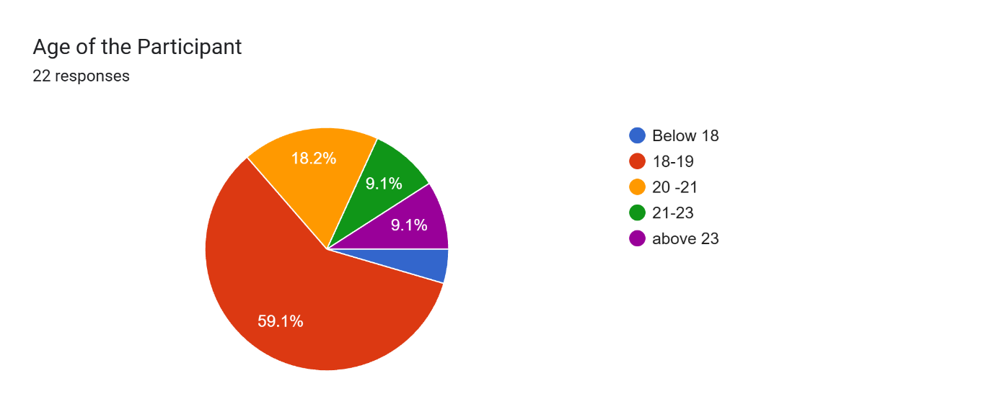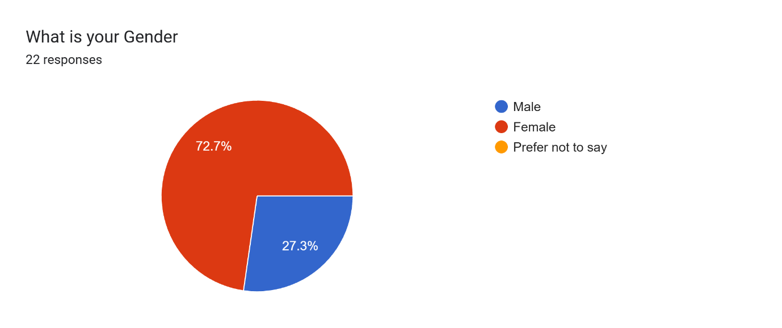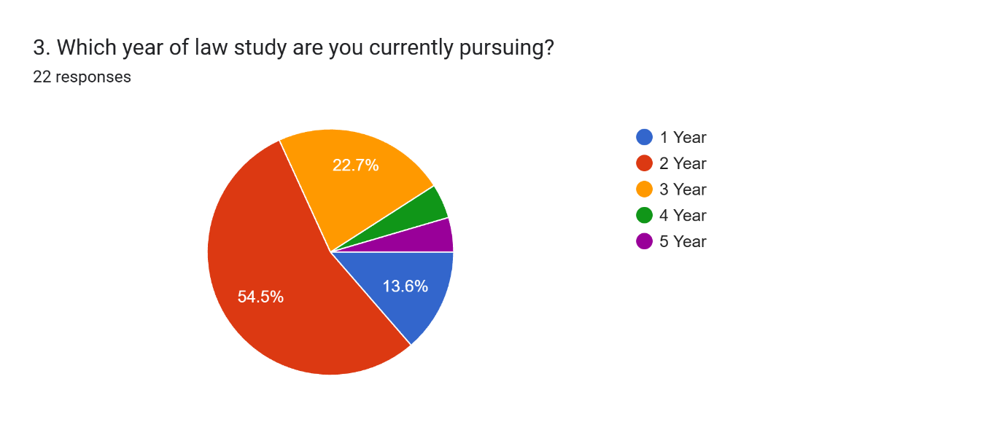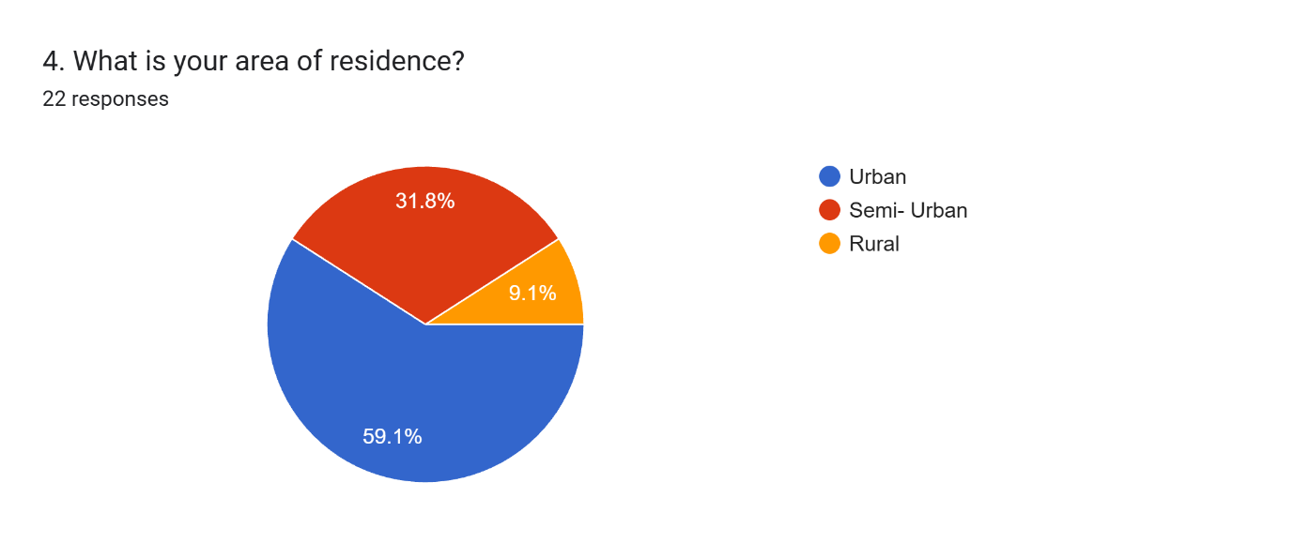

4.1.2 Awareness and Understanding of Solopreneurship
The findings suggest that most respondents were familiar with the concept of solopreneurship and correctly identified a solopreneur as a person independently managing a business or professional service. However, a few respondents demonstrated uncertainty regarding the meaning of the term, reflecting that awareness regarding solopreneurship is still developing among students.
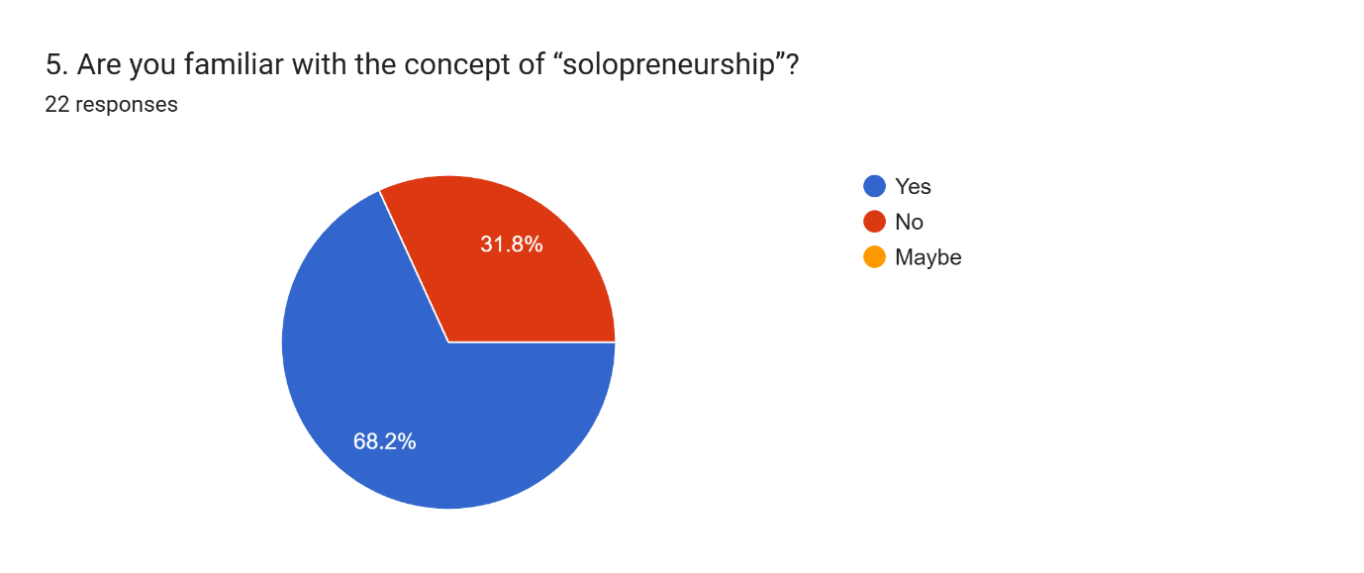
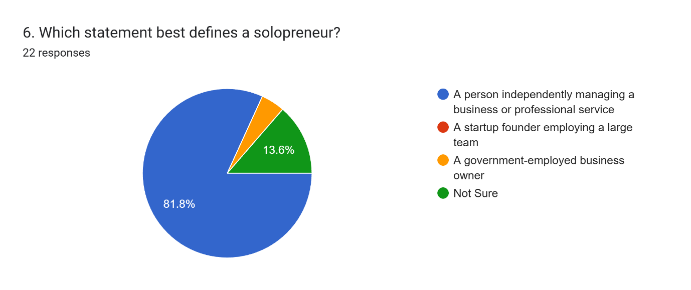
Social media platforms, YouTube, podcasts, blogs, and academic exposure emerged as the major sources through which respondents became aware of solopreneurship. This indicates the increasing role of digital media in influencing entrepreneurial awareness and career aspirations among young individuals.
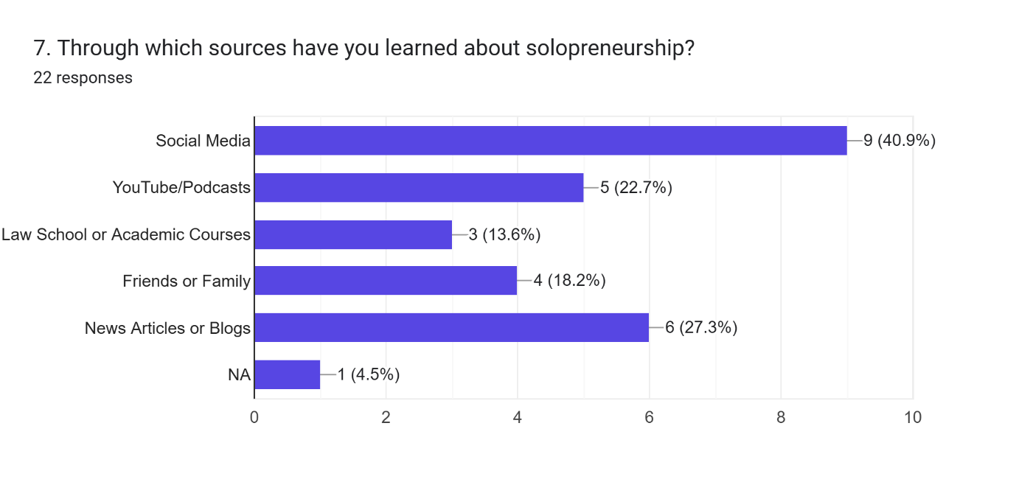
When respondents were asked about their future interest in becoming solopreneurs, the responses reflected mixed opinions. While some participants expressed definite or probable interest in pursuing independent entrepreneurial careers, several respondents remained uncertain. 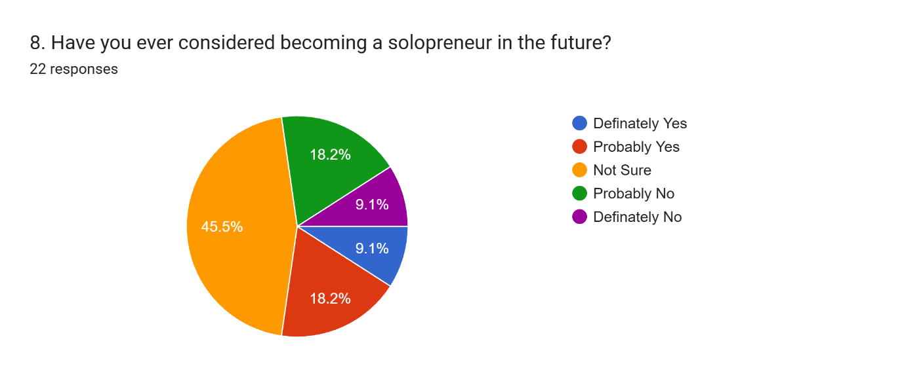Legal consultancy emerged as the most preferred field of interest, followed by freelancing, content creation, and law blogging or vlogging. These findings indicate that students increasingly recognize the possibility of independent professional careers beyond traditional legal employment.
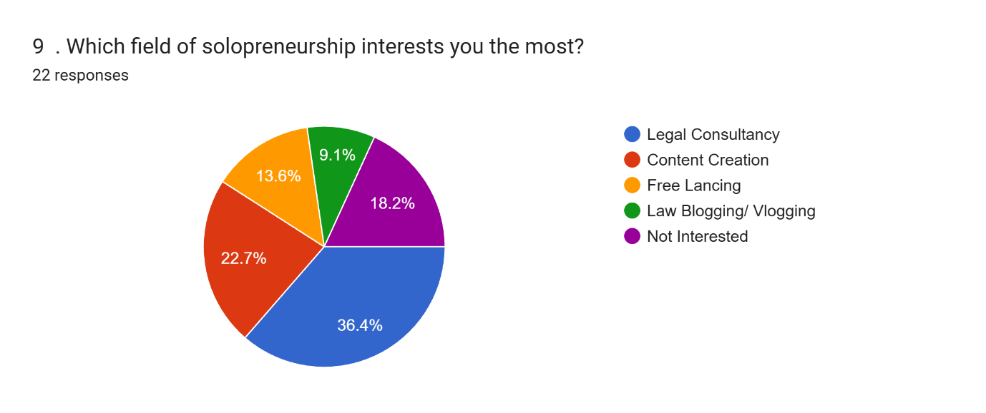

4.1.3 Gender Diversity and Inclusion in Solopreneurship
One of the major objectives of the study was to examine perceptions regarding gender diversity and inclusion in solopreneurship. The findings reveal that respondents held diverse opinions regarding whether solopreneurship provides equal opportunities to all genders. While some participants believed that entrepreneurial opportunities are inclusive, many respondents either disagreed or expressed uncertainty regarding equal accessibility within entrepreneurial ecosystems.
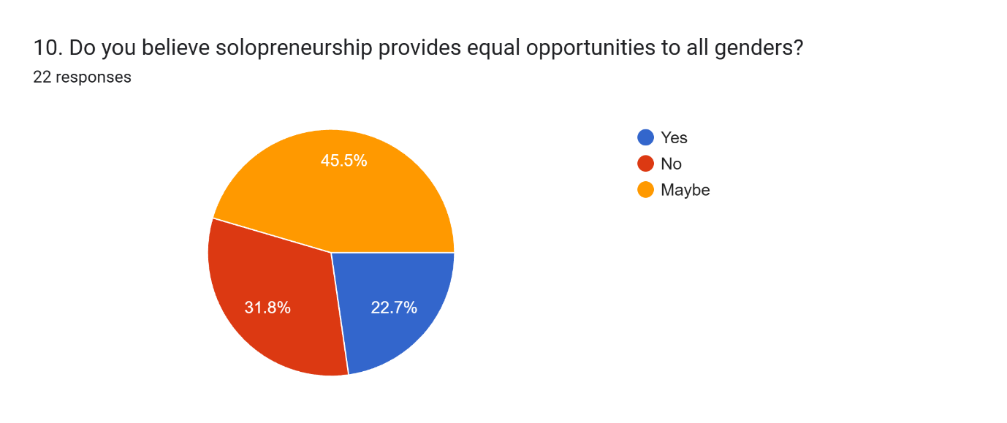
A significant number of respondents believed that women and LGBTQ+ individuals face comparatively greater challenges in solopreneurship.
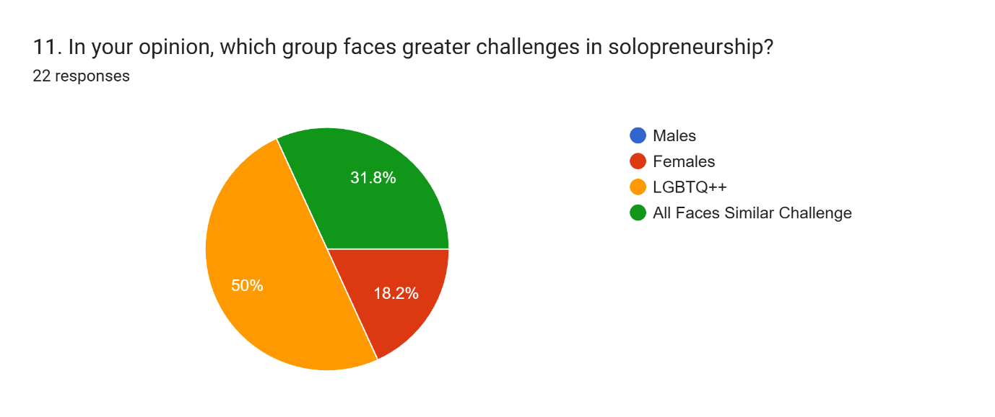
Participants identified several barriers affecting inclusive participation, including lack of financial support, family and societal expectations, safety concerns, digital inequality, lack of mentorship, and lack of confidence or self-doubt. Among these, societal expectations and financial barriers emerged as the most frequently identified challenges.
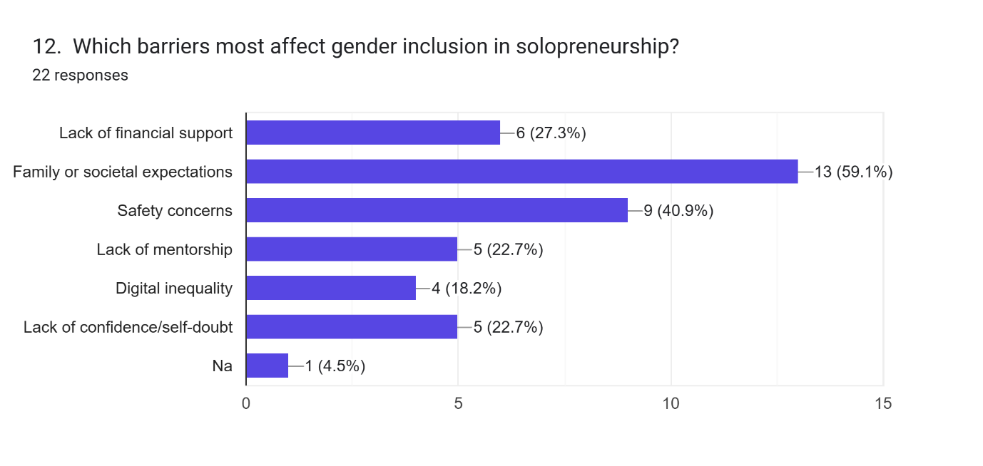

The responses suggest that despite the flexibility associated with solopreneurship, social and structural inequalities continue to influence entrepreneurial participation. The findings reflect broader concerns regarding gender-based discrimination, unequal opportunities, and limited institutional support within professional and entrepreneurial environments.
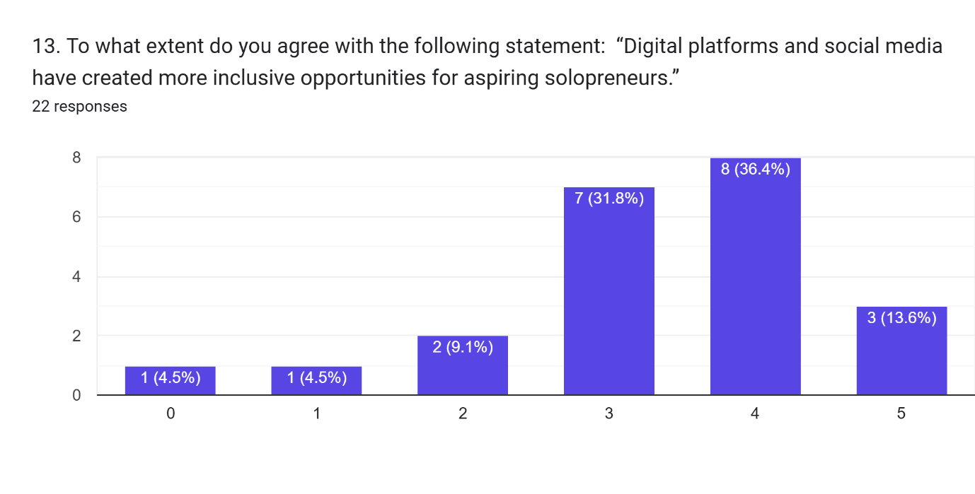

4.1.4 Role of Legal Education in Entrepreneurship
The study further explored whether legal education encourages entrepreneurial thinking among students. Most respondents believed that legal education can contribute to entrepreneurial development and provide advantages in independent professional practice and consultancy-oriented careers.
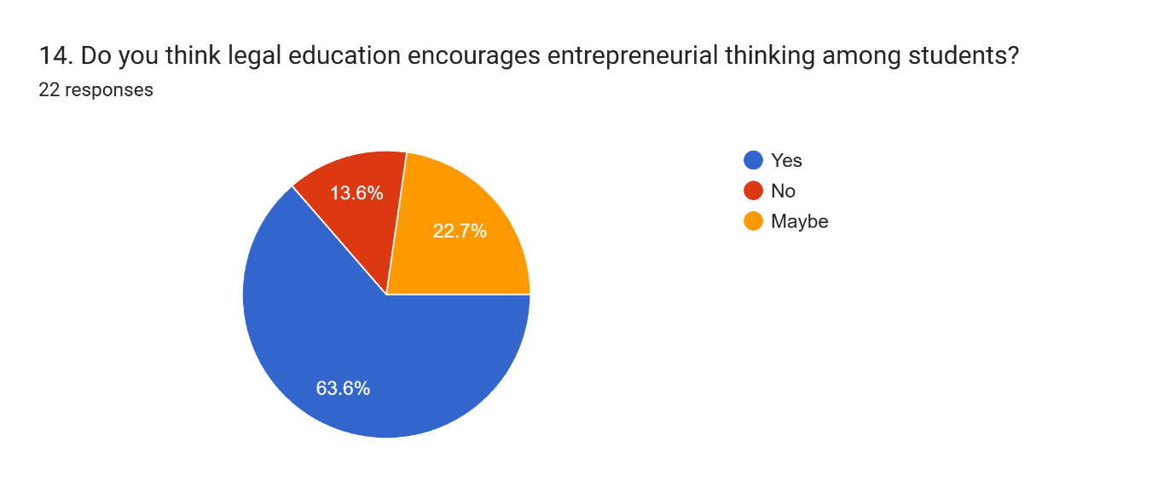

At the same time, some respondents expressed uncertainty regarding the extent to which law schools actively promote entrepreneurship-oriented learning and practical entrepreneurial exposure. This indicates that while students recognize the potential connection between legal education and entrepreneurship, institutional encouragement for entrepreneurial development within legal education remains limited.
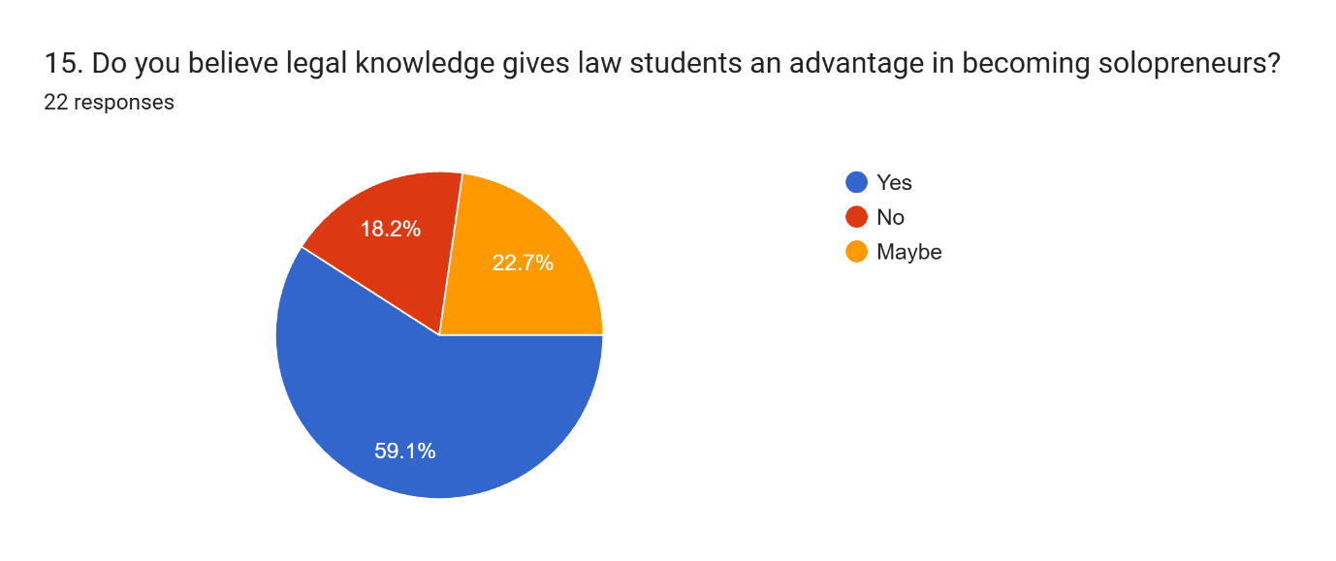
The findings highlight the importance of introducing entrepreneurship-oriented workshops, skill-development programs, legal technology exposure, and practical entrepreneurial training within law schools to encourage innovative and independent professional pathways among students.
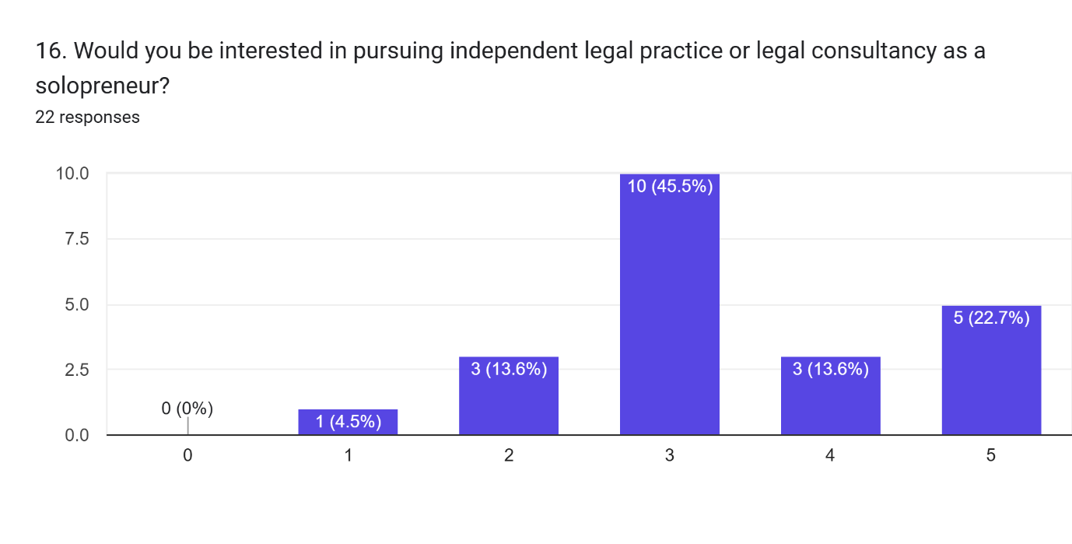

4.1.5 Technology, AI, and Entrepreneurial Inclusion
Technology emerged as one of the most important aspects influencing respondents’ perceptions regarding solopreneurship. Most participants agreed that AI tools and digital technology can reduce barriers in entrepreneurship and create more inclusive opportunities for aspiring solopreneurs. 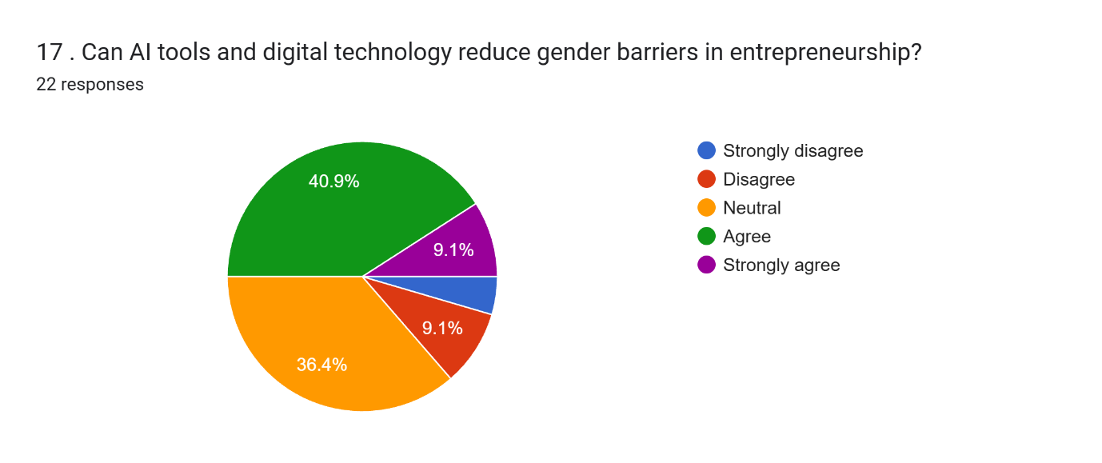

Respondents identified AI tools such as ChatGPT and Canva AI, social media marketing platforms, LinkedIn, legal technology platforms, and online learning resources as valuable tools supporting entrepreneurial growth and accessibility. The findings further indicate that students strongly associate technological access with entrepreneurial success in the modern digital economy.
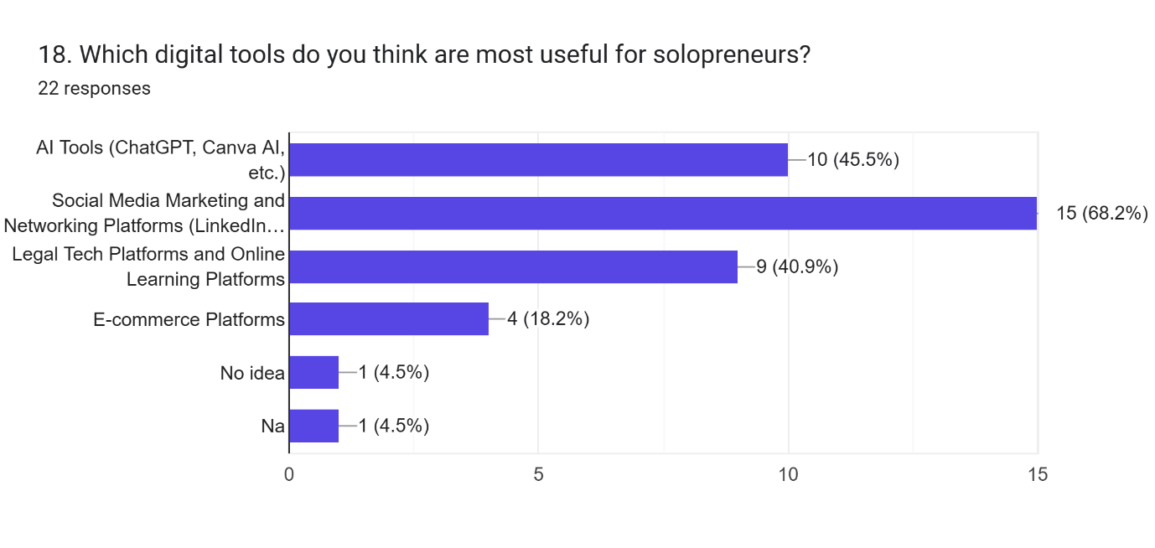
However, the study also identified digital inequality as an important concern affecting entrepreneurial inclusion. While technology can create opportunities for independent work and professional growth, unequal access to digital resources and technological literacy may continue to limit inclusive participation among different social groups.
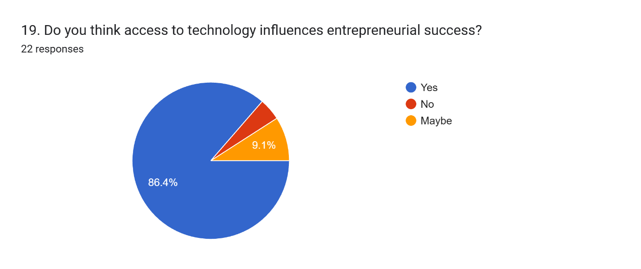

4.1.6 Major Findings of the Study
The study reveals several important findings regarding gender diversity and inclusion in solopreneurship among law students. First, awareness regarding solopreneurship exists among students, primarily due to digital and social media exposure. Second, legal consultancy, freelancing, and digital content creation are increasingly perceived as potential independent career opportunities within the legal field.
Third, respondents perceive women and LGBTQ+ individuals as facing comparatively greater barriers in entrepreneurial environments. Financial inequality, societal expectations, safety concerns, digital inequality, and lack of mentorship emerged as major challenges affecting inclusive participation.
Finally, technology and AI tools were widely viewed as important mechanisms for promoting entrepreneurial accessibility and inclusion. Respondents also acknowledged the growing importance of legal education in supporting entrepreneurial thinking, although greater institutional support and practical entrepreneurial exposure remain necessary.

5.1 Discussion and Theoretical Framework

5.1.1 Theory of Planned Behaviour and Entrepreneurial Intention
The present study is primarily guided by the Theory of Planned Behaviour (TPB) developed by Icek Ajzen, which explains that entrepreneurial intention is influenced by attitude toward entrepreneurship, subjective norms, and perceived behavioural control. According to the theory, individuals are more likely to engage in entrepreneurial activities when they possess positive attitudes toward entrepreneurship, receive social support, and believe they have the capability to successfully perform entrepreneurial tasks. (Ajzen, 1991)
BI = A + SN + PBC
The findings of the present study strongly support the relevance of this theoretical perspective. Most respondents demonstrated awareness regarding solopreneurship and identified legal consultancy, freelancing, and content creation as attractive entrepreneurial opportunities. The responses indicate that students increasingly perceive independent professional careers as viable alternatives within the evolving digital economy. These findings correspond with previous studies that identified entrepreneurial attitude and perceived self-efficacy as strong predictors of entrepreneurial intention among students. Krueger et al. (2000)
At the same time, several respondents expressed uncertainty regarding whether they would pursue solopreneur careers in the future. This uncertainty may be linked to perceived behavioural control and subjective norms, as respondents identified financial barriers, societal expectations, lack of mentorship, and self-doubt as major challenges affecting entrepreneurial participation. The findings therefore reinforce earlier empirical research suggesting that entrepreneurial intention is significantly influenced by social support systems, confidence, and perceived capability. Liñán and Chen (2009)

5.1.2 Social Role Theory and Gender Inclusion
The study is further supported by Social Role Theory, which explains that gender differences in professional participation often arise due to socially constructed expectations and cultural stereotypes associated with masculinity and femininity. According to the theory, society assigns different social responsibilities and behavioural expectations to men and women, thereby influencing confidence, leadership opportunities, entrepreneurial participation, and professional visibility. (Eagly1987)
The findings of the present study demonstrate that respondents perceive women and LGBTQ+ individuals as facing comparatively greater barriers within entrepreneurial ecosystems. Respondents identified societal expectations, lack of financial support, safety concerns, lack of mentorship, and digital inequality as major obstacles affecting inclusive participation in solopreneurship. These findings indicate that entrepreneurial environments continue to be influenced by broader social and structural inequalities despite increasing accessibility through digital platforms.
The findings correspond with earlier studies that found women are often less likely to translate entrepreneurial intention into entrepreneurial action due to social stereotypes, unequal institutional support, and cultural expectations. Previous empirical research applying Social Role Theory similarly concluded that gender moderates the relationship between entrepreneurial intention and entrepreneurial behaviour. Block et al. (2019) The present study therefore reinforces the argument that gender inclusion remains a significant challenge within entrepreneurial and professional ecosystems.

5.1.3 Entrepreneurial Self-Efficacy and Legal Education
The present study also draws upon the concept of Entrepreneurial Self-Efficacy developed from the work of Albert Bandura. Entrepreneurial self-efficacy refers to an individual’s belief in their ability to successfully perform entrepreneurial tasks and make entrepreneurial decisions. Individuals with stronger entrepreneurial confidence are generally more likely to pursue entrepreneurial opportunities and engage in entrepreneurial behaviour. Bandura (1997) The findings of the study indicate that most respondents believe legal education can encourage entrepreneurial thinking and provide advantages in independent professional practice and consultancy-oriented careers. Respondents also acknowledged the importance of digital tools, AI platforms, and technological resources in supporting entrepreneurial accessibility and professional independence. These findings suggest that educational exposure and technological literacy positively influence entrepreneurial confidence among students.
The findings align with previous research demonstrating that entrepreneurship education positively influences entrepreneurial self-efficacy and entrepreneurial intention. Studies conducted among university students found that entrepreneurship education strengthens entrepreneurial decision-making confidence and increases entrepreneurial participation among students (Cai et al. (2023). The present findings similarly suggest that integrating entrepreneurship-oriented workshops, practical training, and legal technology exposure within legal education may strengthen entrepreneurial confidence and entrepreneurial participation among law students.

5.1.4 Technology, AI, and Inclusive Solopreneurship
Another important finding of the present study relates to the role of technology and AI in promoting inclusive entrepreneurial opportunities. Most respondents agreed that digital technology and AI tools can reduce barriers within entrepreneurship and create more accessible opportunities for aspiring solopreneurs. AI tools such as ChatGPT and Canva AI, social media platforms, LinkedIn, legal technology platforms, and online learning resources were identified as important tools supporting entrepreneurial growth and professional accessibility.
These findings support previous studies emphasizing that digital platforms and technological innovation have transformed entrepreneurship by lowering entry barriers and enabling independent professional participation. Technology allows individuals to market services, access clients, develop professional networks, and build entrepreneurial careers without requiring extensive organizational structures or large financial investments. (Jones and English (2004))
However, respondents also identified digital inequality as a major barrier affecting inclusive participation in solopreneurship. This indicates that although technology can democratize entrepreneurial opportunities, unequal access to digital resources and technological literacy may continue to reinforce social and economic inequalities. The findings therefore highlight the importance of ensuring equal technological accessibility and digital literacy to promote inclusive participation in entrepreneurship.

5.1.5 Overall Discussion
The findings of the present study demonstrate that law students increasingly recognize solopreneurship as a viable and flexible professional pathway within the modern digital economy. The study reveals growing awareness regarding entrepreneurship, independent legal practice, freelancing, and technology-enabled professional opportunities among students. At the same time, the findings also indicate that gender-based barriers, financial inequality, societal expectations, lack of mentorship, and safety concerns continue to influence entrepreneurial participation and inclusion.
The study further demonstrates that technology and AI tools are widely perceived as mechanisms capable of enhancing entrepreneurial accessibility and reducing professional barriers. However, inclusive participation within solopreneurship still depends upon broader educational support systems, mentorship opportunities, institutional encouragement, and equal digital accessibility.
The combined application of the Theory of Planned Behaviour, Social Role Theory, and Entrepreneurial Self-Efficacy Theory provides a comprehensive framework for understanding how entrepreneurial intention, gender norms, educational exposure, confidence, and technological accessibility collectively influence perceptions regarding solopreneurship among law students. Although the study is limited by its relatively small sample size, it contributes important preliminary empirical insights into gender diversity and inclusion within emerging entrepreneurial ecosystems.

Conclusion and Suggestions

6.1.1 Conclusion
This study shows that solopreneurship is not just an alternative career choice anymore; it's a growing expression of independence, flexibility, and digital empowerment among law students. The findings reveal that students increasingly link entrepreneurship with legal consulting, freelancing, content creation, and technology-driven professional independence. However, beneath this rising enthusiasm, there remains a persistent issue of unequal access and structural exclusion. The study uncovers a significant contradiction in today’s entrepreneurial culture. While people often celebrate digital platforms and AI tools as equalizers, the responses indicate that social realities still influence entrepreneurial participation. Women and LGBTQ+ individuals face greater barriers due to societal expectations, safety concerns, financial inequality, lack of mentorship, and limitations in confidence. This shows that technology alone cannot break down deep-rooted social hierarchies. Accessibility without inclusivity merely reproduces inequality in a digital format.
At the same time, the study emphasizes a major shift in legal education. Law students are increasingly viewing legal knowledge not just as a way into litigation or corporate jobs, but also to create independent professional identities. Still, institutional support for entrepreneurial thinking is often limited and leans more toward theory than practice. In the end, the study argues that we cannot achieve inclusive solopreneurship just through technological innovations or motivational talks. True inclusion needs structural support, gender-sensitive policies, mentorship, financial accessibility, and educational reform. Solopreneurship can democratize opportunity, but only if entrepreneurial systems are designed to include those who have historically been marginalized, rather than merely adapting old inequalities to new digital environments.

6.1.2 Suggestions
1. Introduction of Entrepreneurship Education in Law Schools: Law schools should introduce courses, workshops, and hands-on training focused on entrepreneurship. This approach can encourage students to think like entrepreneurs. By exposing students to legal consulting, freelancing, legal-tech platforms, and digital business management, we can boost their entrepreneurial confidence and professional independence. Previous studies show that entrepreneurship education positively impacts students' entrepreneurial intentions and self-belief. (Cai et al. (2023))
2. Strengthening Mentorship and Support Networks: The study found that a lack of mentorship is a major barrier to participation in solopreneurship. Educational institutions and professional organizations should create mentorship programs, networking opportunities, and guidance initiatives especially for women and LGBTQ+ individuals. Strong mentorship can significantly enhance confidence, decision-making, and career opportunities. (Bandura (1997))
3.Promoting Gender-Inclusive Entrepreneurial Policies: The findings showed that family expectations, societal stereotypes, and safety concerns continue to hinder gender inclusion in entrepreneurship. Institutions and policymakers should promote policies that are sensitive to gender issues, along with awareness programs and inclusive workplace practices. These steps can help reduce discrimination and foster equal participation in entrepreneurial settings. Previous research highlights that gender stereotypes still shape entrepreneurial behaviour and career opportunities. (Eagly (1987))
4. Enhancing Digital Accessibility and Technological Literacy: Most respondents believe that AI tools and digital technology can lower barriers to entrepreneurship. Therefore, efforts should focus on improving digital literacy and access to technology for students. Training on AI tools, social media marketing, legal tech platforms, and online networking should be encouraged to support technology-driven entrepreneurship. At the same time, addressing digital inequality is essential for fostering inclusive participation in entrepreneurship. (Nambisan,2017)
5. Providing Financial and Institutional Support for Young Solopreneurs: The study identified financial limitations as a key barrier to entrepreneurial participation. Universities, government institutions, and startup incubation centres should offer financial help, startup grants, internship opportunities, and support for new businesses to aspiring young solopreneurs. Institutional support and accessible funding can assist students in turning their entrepreneurial intentions into actions. (Block et al,2019)

7.1 References

A. Journal Articles
- Ajzen, I., “The Theory of Planned Behaviour,” 50 Organizational Behaviour and Human Decision Processes 179–211 (1991).
https://doi.org/10.1016/0749-5978(91)90020-T
- Ajzen, I., “Perceived Behavioural Control, Self-Efficacy, Locus of Control, and the Theory of Planned Behaviour,” 32 Journal of Applied Social Psychology 665–683 (2002).
https://onlinelibrary.wiley.com/doi/10.1111/j.1559-1816.2002.tb00236.x
- Krueger, N. F., Reilly, M. D. & Carsrud, A. L., “Competing Models of Entrepreneurial Intentions,” 15 Entrepreneurship Theory and Practice 411–432 (2000).
https://journals.sagepub.com/doi/10.1177/104225879001500307
- Liñán, F. & Chen, Y. W., “Development and Cross-Cultural Application of a Specific Instrument to Measure Entrepreneurial Intentions,” 33 Entrepreneurship Theory and Practice 593–617 (2009).
https://onlinelibrary.wiley.com/doi/10.1111/j.1540-6520.2009.00318.x
- Block, J. H., Fisch, C. & Van Praag, M., “Do Intentions Predict Entrepreneurial Behavior? Examining the Moderating Role of Gender,” 57 Journal of Small Business Management 226–240 (2019).
https://onlinelibrary.wiley.com/doi/10.1111/jsbm.12354
- Marlow, S. & McAdam, M., “Gender and Entrepreneurship: Advancing Debate and Challenging Myths,” 27 International Journal of Entrepreneurial Behavior & Research 1–16 (2021).
https://www.emerald.com/insight/content/doi/10.1108/IJEBR-06-2020-0423/full/html
- Cai, Y., Wang, R. & Chen, X., “Entrepreneurship Education and Entrepreneurial Intention among College Students,” 14 Frontiers in Psychology 1–14 (2023).
https://www.frontiersin.org/articles/10.3389/fpsyg.2023.1105409/full
- Nambisan, S., “Digital Entrepreneurship: Toward a Digital Technology Perspective of Entrepreneurship,” 35 Entrepreneurship Theory and Practice 1029–1055 (2017).
https://journals.sagepub.com/doi/10.1111/etap.12254
- Jones, C. & English, J., “A Contemporary Approach to Entrepreneurship Education,” 46 Education + Training 416–423 (2004).
https://www.emerald.com/insight/content/doi/10.1108/00400910410569533/full/html
- Obschonka, M., Schmitt-Rodermund, E. & Silbereisen, R. K., “Entrepreneurial Self-Identity and the Development of Entrepreneurial Intentions,” 52 Journal of Vocational Behavior 1–15 (2015).
https://www.sciencedirect.com/science/article/pii/S0001879115000036
- Aldrich, H. E. & Cliff, J. E., “The Pervasive Effects of Family on Entrepreneurship,” 25 Journal of Business Venturing 573–596 (2003).
https://www.sciencedirect.com/science/article/pii/S0883902603000119

B. Books
- Bandura, A., Self-Efficacy: The Exercise of Control (W.H. Freeman and Company, 1997).
https://openlibrary.org/books/OL1011521M/Self-efficacy
- Eagly, A. H., Sex Differences in Social Behavior: A Social-Role Interpretation (Lawrence Erlbaum Associates, 1987).
https://psycnet.apa.org/record/1987-97327-000
- Warschauer, M., Technology and Social Inclusion: Rethinking the Digital Divide (MIT Press, 2003).
https://mitpress.mit.edu/9780262731738/technology-and-social-inclusion/
- Audretsch, D. B., Entrepreneurship and Economic Growth (Oxford University Press, 2007).
https://global.oup.com/academic/product/entrepreneurship-and-economic-growth-9780195183512

C. Research Papers and Academic Studies
- “Entrepreneurship Education and Entrepreneurial Intention among College Students,” Frontiers in Psychology (2023).
https://www.frontiersin.org/articles/10.3389/fpsyg.2023.1105409/full
- “Digital Entrepreneurship: Toward a Digital Technology Perspective of Entrepreneurship,” Entrepreneurship Theory and Practice (2017).
https://journals.sagepub.com/doi/10.1111/etap.12254
- “Gender and Entrepreneurship: Advancing Debate and Challenging Myths,” International Journal of Entrepreneurial Behavior & Research (2021).
https://www.emerald.com/insight/content/doi/10.1108/IJEBR-06-2020-0423/full/html
- “Development and Cross-Cultural Application of a Specific Instrument to Measure Entrepreneurial Intentions,” Entrepreneurship Theory and Practice (2009).
https://onlinelibrary.wiley.com/doi/10.1111/j.1540-6520.2009.00318.x

