ASSESSING THE NEED OF ANALYTICAL, COGNITIVE, AND TECHNICAL
SKILLS IN THE LEGAL PROFESSION: AN EMPIRICAL RESEARCH AT NLU, NAGPUR
- By Shrushti Taori and Karishma Lambat
Students at Maharashtra National Law University, Nagpur

Abstract
This survey explores student perceptions of their own analytical, cognitive, and technical skills at Maharashtra National Law University, Nagpur, within this doctrinal and policy context. By surveying students across batches, the study identifies where confidence is strong and where it lags.
This survey evaluates the analytical (avg. 2.86), cognitive (avg. 2.88), and technical skills (avg. 2.92) of over 100 law students at Maharashtra National Law University, Nagpur, to determine their preparedness for contemporary legal practice. Students report the highest confidence in structured tasks like applying precedents (2.59) and using Boolean search operators (2.71), but struggle with deeper synthesis, such as identifying logical gaps in judgments (3.07) and sustaining focus on extensive documents (3.37). The results indicate that conventional teaching methods provide a sound doctrinal foundation but do not fully equip students for the complex and dynamic challenges of professional practice. Skill development is also shaped significantly by moots, internships, and peer learning, thus highlighting the importance of co-curricular and experiential opportunities. However, the current framework continues to overemphasize rote assessments and insufficiently integrates practical training or legal technology.
The study recommends early integration of skill-based modules, reforms in assessment practices to privilege reasoning over memorisation, and expansion of experiential platforms such as legal clinics and structured industry engagement. These measures would support a more student-centred and outcome-driven model of legal education, fostering not only doctrinal proficiency but also adaptability, critical thinking, and professional readiness.
Keywords: Analytical Skills, Cognitive Skills, Legal Education, Maharashtra National Law University Nagpur, Technical Skills.

- Introduction
Legal education in India is increasingly expected to transcend the traditional teaching of statutes and cases. The National Education Policy, 2020 (“NEP 2020”) explicitly calls for a more multidisciplinary, experiential, and skills-oriented approach, recognising that graduates must be prepared for both theory and practice. To enhance accessibility and inclusivity, the NEP 2020 emphasises the adoption of technology, early professional and vocational training, and the provision of legal education in regional languages. The statutory and regulatory framework reinforces these norms under Section 7(1)(h) of the Advocates Act, 1961, which tasks the Bar Council of India (“BCI”) with promoting and laying down standards for legal education. These standards are further stipulated in the BCI’s Rules on Standards of Legal Education, 2008, which provide for the recognition of degrees and the inspection of universities.
However, doctrinal literature identifies significant gaps between these regulatory mandates and actual delivery. While rules exist for clinical legal education and internships, many law schools remain ‘heavily doctrinal’ with limited experiential exposure. Even when regulatory standards are met, developing the specific skillsets required by the industry remains a distinct challenge.
This report details the findings of a comprehensive survey conducted among over 100 law students at NLU, Nagpur, to assess self-reported proficiency in analytical, cognitive, and technical skills. The primary objectives are to evaluate these key skill areas, identify strengths and gaps by determining which tasks students find challenging, and provide an empirical basis for targeted curricular reforms. Ultimately, this survey serves as a diagnostic tool to bridge the gap between current educational practices and the evolving demands of the legal profession, promoting a holistic model that fuses theoretical rigor with practical skill development.

- Objective
The primary objectives of this survey are to:
- Evaluate Key Skill Areas: Assess the levels of analytical, cognitive, and technical skills among the students.
- Identify Strengths and Gaps: Determine which tasks students find relatively easy and which they perceive as challenging.
- Inform Future Reforms: Provide an empirical basis for recommending targeted improvements in legal education to better prepare students for real-world practice.
- Purpose
The survey serves to bridge the gap between current educational practices and the evolving demands of the legal profession. It aims to:
- Offer a clear diagnostic of student competencies.
- Enable academic stakeholders to tailor interventions that address identified shortcomings.
- Promote a holistic educational approach that fuses theoretical rigor with practical skill development.
- Methodology
- Data Collection:
The questionnaire was circulated electronically, with students voluntarily participating across various batches. With 100 responses were received, ensuring a robust sample for statistical analysis.
- Survey Structure:
  - Closed-Ended Questions: These are based on a 5-point Likert scale rating various tasks, enabling quantitative measurement of perceived ease or difficulty.
  - Open-Ended Questions: These provided additional qualitative insights, allowing respondents to comment on their experiences and offer suggestions for improvement.
- Data Analysis:
Quantitative data were aggregated to calculate average scores for each skill-specific task, while qualitative feedback was reviewed to provide context and depth to the numerical findings.
- Scope and Limitations
- Scope:
The survey is focused on capturing the current state of legal skills among students at NLU, Nagpur. It examines self-reported abilities in specific analytical, cognitive, and technical tasks to identify trends and inform future curriculum development.
- Limitations:
Respondents’ self-assessments might reflect subjective perceptions rather than objective measures of competence. Moreover, the findings are based on responses from a single institution and may not be generalized to all legal education contexts. Furthermore, the survey captures data at a single point in time. Skill levels may evolve, necessitating periodic reassessment.

- Analysis and Result of Survey

- Analytical Skills: Ability to break down information, spot patterns, draw connections. e.g., Identifying logical gaps in a court judgment.
Avg. Score - 2.862
- Cognitive Skills: Mental processes involved in learning, understanding, problem-solving. e.g., Extracting underlying doctrine from complex texts.
Avg. Score - 2.881.
- Technical Skills: Task-specific abilities often involving tools/technology. e.g., Creating Excel formulas or drafting legal agreements.
Avg. Score - 2.917

- Analytical Skills
Analytical skills are foundational for legal reasoning - encompassing the abilities to dissect complex texts, identify critical gaps in judicial reasoning, and synthesize legal doctrines. The students’ responses, measured on a Likert scale from 1 (easy) to 5 (difficult), provide insight into which tasks they perceive as more approachable and which require further instructional support.
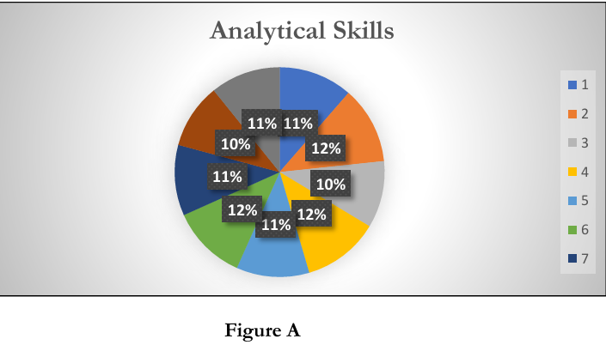
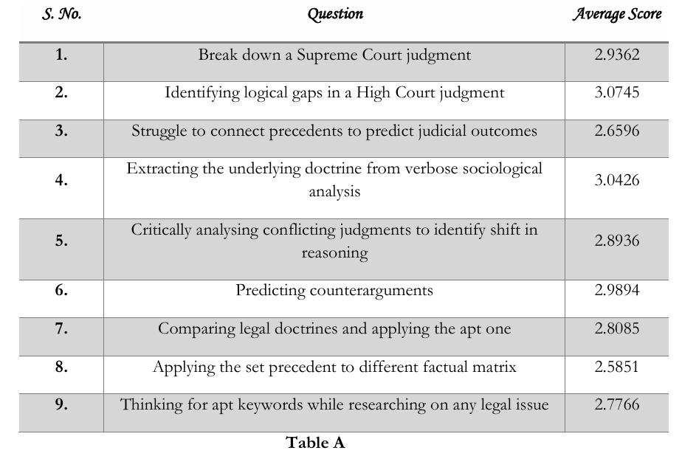
- Tasks Perceived as Relatively Easier (Scores Closer to 2)
• Applying the set precedent to different factual matrix (Average Score: 2.5851): Although this task inherently involves adapting precedents to novel scenarios, the relatively lower score indicates that a subset of students has developed basic competence in navigating traditional precedential applications. This may result from repeated exposure to model cases and classroom exercises that emphasize direct applications.
• Comparing legal doctrines and applying the apt one (Average Score: 2.8085):
This task, which involves evaluating multiple doctrinal perspectives, garners a moderately lower difficulty rating. Students seem to demonstrate comfort in making comparative analyses, likely due to familiarization through doctrinal lectures and case studies that stress comparison as a standard academic exercise.
• Thinking for apt keywords while researching on any legal issue (Average Score: 2.7766):
This skill, vital for effective legal research, is perceived as moderately challenging yet remains on the easier side relative to other analytical tasks. The training provided in constructing search queries or utilizing legal databases appears to be effective at a foundational level.
- Tasks with Elevated Difficulty (Scores Approaching or Exceeding 3)
• Identifying logical gaps in a High Court judgment (Average Score: 3.0745):
This task received the highest average rating, indicating that students struggle with detecting subtle inconsistencies and errors in judicial reasoning. The complexity inherent in higher court decisions, which often involve nuanced and layered argumentation, likely contributes to the increased difficulty.
• Extracting the underlying doctrine from verbose sociological analysis (Average Score: 3.0426):
Tasks that require distilling dense academic or sociological commentary into clear doctrinal principles are perceived as challenging. The moderately high score suggests that while students can manage textual analysis, the transition from descriptive to analytical reasoning remains an area for improvement.
• Predicting counterarguments (Average Score: 2.9894):
Generating plausible counterarguments requires foresight and a deep understanding of both the strengths and weaknesses of a legal position. This task’s score, just at the threshold of moderate difficulty, reflects the cognitive demands of anticipating opposing views.
• Break down a Supreme Court judgment (Average Score: 2.9362) and Critically analyzing conflicting judgments to identify a shift in reasoning (Average Score: 2.8936):
While these tasks score slightly below 3, they are indicative of moderate difficulty. They require systematic deconstruction of complex judgments and synthesis of conflicting viewpoints, skills that are crucial for advanced legal analysis. The scores suggest that students are reasonably competent, yet there remains scope for further enhancement through targeted training.
Interpretation and Pedagogical Implications
The overall pattern indicates that students are relatively more confident in tasks grounded in comparison and direct application, which likely align with structured classroom practices. In contrast, tasks that necessitate deeper synthesis, such as identifying subtle logical inconsistencies or extracting doctrines from complex texts, are rated as moderately more difficult (scores around 3 or slightly above).
- Cognitive Skills
Cognitive skills in the legal context encompass memory, focused reading, adaptive reasoning, and the ability to articulate complex arguments under pressure. In the questionnaire, students assessed their performance in key cognitive tasks on a scale where lower scores indicate relative ease and higher scores indicate increased difficulty. The average scores for these tasks fall in the range of approximately 2.63 to 3.37, revealing distinct areas of strength and challenge.
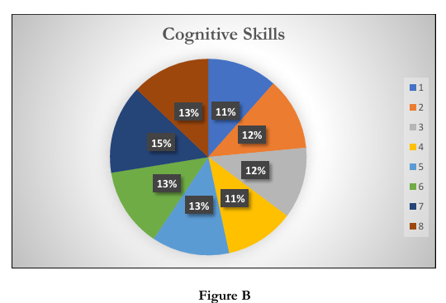
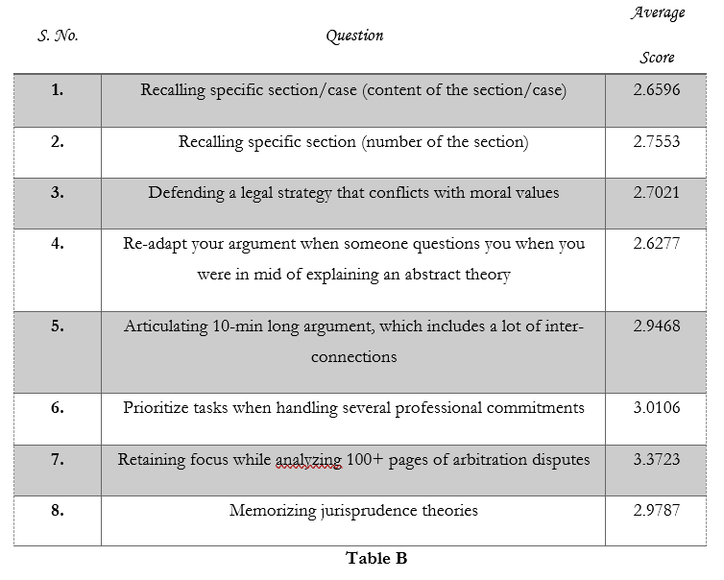
- Tasks Perceived as Relatively Easier (Scores Closer to 2)
• Re-adapt your argument when someone questions you when you were in mid of explaining an abstract theory (Average Score: 2.6277):
This task, which asks students to modify or defend their line of reasoning on-the-fly, garnered the lowest average score among cognitive skills. This finding suggests that students feel fairly competent in adapting their arguments, possibly due to practice in classroom debates and moot court exercises where spontaneity is regularly required.
• Recalling specific section/case (content of the section/case) (Average Score: 2.6596): The ability to remember and reproduce detailed content of a section or case is rated relatively low in difficulty. This indicates that students are likely well-versed in the foundational aspects of legal texts, possibly due to strong memorization techniques reinforced through traditional legal study.
• Recalling specific section (number of the section) (Average Score: 2.7553):
Similar to recalling case content, remembering the precise numerical designation of a legal section is perceived as moderately easy. This skill is typically emphasized during statutory learning and case-law analysis, contributing to its relatively lower difficulty rating.
- Tasks with Elevated Difficulty (Scores Approaching or Exceeding 3)
• Defending a legal strategy that conflicts with moral values (Average Score: 2.7021): Although closely grouped with recall tasks, defending a legal strategy that may run counter to one's moral inclinations presents a nuanced challenge. The slightly higher difficulty suggests that while students understand legal doctrine, the emotional and ethical complexities involved add an extra layer of cognitive stress.
• Articulating a 10-min long argument, which includes a lot of inter-connections (Average Score: 2.9468):
Formulating and delivering a sustained argument that weaves together multiple points and legal principles is moderately challenging. The score nearing 3 reflects the cognitive load required to maintain clarity, coherence, and persuasiveness throughout an extended oral presentation. • Prioritize tasks when handling several professional commitments (Average Score: 3.0106):
Task prioritization in a busy professional or academic setting appears to be one of the more challenging cognitive skills. The higher rating in this category indicates that students find managing and ordering multiple responsibilities particularly demanding, suggesting a need for better time-management and organizational strategies.
• Retaining focus while analyzing 100+ pages of arbitration disputes (Average Score: 3.3723):
The highest average rating among cognitive tasks is observed for sustaining concentration over extensive and complex texts. This task demands prolonged mental engagement and the ability to filter and extract pertinent information, marking it as the most cognitively taxing area among those examined.
• Memorizing jurisprudence theories (Average Score: 2.9787):
While memorization tasks generally fare better, this aspect still sits near the moderate level of difficulty. This suggests that while the basic recall may be well-ingrained, the abstract nature of jurisprudence theories poses a distinct challenge compared to more concrete information.
Interpretation and Pedagogical Implications
The pattern of responses in the cognitive skills section reveals that students are most comfortable with tasks that primarily involve straightforward recall or rapid adaptation of arguments. In contrast, tasks requiring extended concentration and complex multitasking, particularly those involving extensive document analysis and prioritization under professional commitments, are perceived as more difficult.
- Technical Skills
Technical skills in legal education encapsulate a range of task-specific abilities, including document formatting, practical use of legal research tools, drafting legal documents, and applying specialized rules of interpretation. The students’ ratings—averaging between approximately 2.71 and 3.04— indicate that while these skills are generally within reach, certain tasks still impose moderate difficulty.
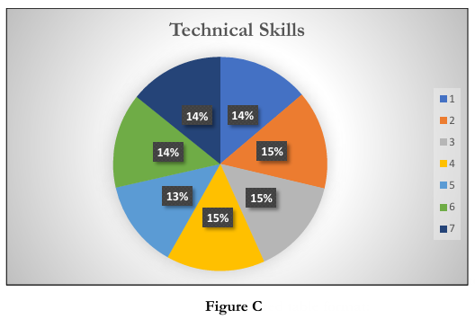

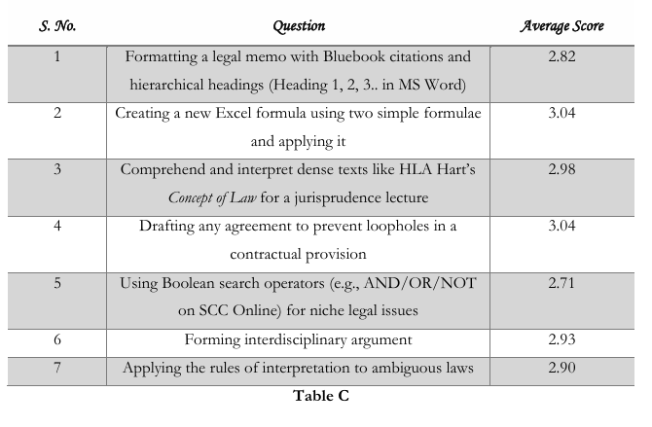
- Tasks Perceived as Relatively Easier
• Using Boolean Search Operators (Average Score: 2.71):
The task of executing searches using Boolean operators (e.g., AND/OR/NOT) on platforms like SCC Online received the lowest average score. This lower rating suggests that most students have attained a foundational competency in legal research techniques, likely through routine database exercises and targeted training sessions.
• Formatting a Legal Memo with Bluebook Citations and Hierarchical Headings (Average Score: 2.82):
The process of organizing a legal memo—though detail-oriented—is perceived as relatively easier. Familiarity with citation rules and the structured nature of document formatting appears to equip students to perform this task with reasonable confidence.
- Tasks with Moderately Elevated Difficulty
• Creating a New Excel Formula Using Two Simple Formulae (Average Score: 3.04):
Formulating and applying a new Excel formula, although conceptualized with basic operations, presents a slightly higher challenge. This might reflect a gap in integrating technical tool usage with legal problem-solving, an area that could benefit from additional practical exposure and guided exercises.
• Drafting Any Agreement to Prevent Loopholes in a Contractual Provision (Average Score: 3.04):
Drafting agreements requires precision and an advanced understanding of contractual language. The moderate difficulty indicated by its average score suggests that while students are comfortable with some aspects of legal drafting, the creation of robust, loophole-proof agreements remains a challenge that necessitates further focused training.
• Comprehend and Interpret Dense Texts Such as HLA Hart’s Concept of Law (Average Score: 2.98): Interpreting dense, doctrinal texts involves not only reading comprehension but also the ability to extract and apply relevant legal concepts. This task’s average rating near 3 reflects the inherent challenge in dealing with abstract legal theories, compounded by the technicality of translating them into practical insights.
• Forming an Interdisciplinary Argument (Average Score: 2.93) and Applying the Rules of Interpretation to Ambiguous Laws (Average Score: 2.90):
Both these tasks require integrating complex ideas and applying structured methodologies. They demonstrate moderate difficulty, suggesting that while students are making strides in employing technical methods to bridge different legal disciplines, there is room for deepening their analytical rigor and adaptability.
Interpretation and Pedagogical Implications The overall pattern in the technical skills section reveals that students are generally proficient in areas where there is a clear, structured methodology—such as Boolean searches and memo formatting. However, tasks that demand a higher level of synthesis and the integration of complex legal concepts with technical precision (e.g., drafting agreements, constructing formulas, and interpreting dense doctrinal texts) are comparatively more challenging.
- Facts Contributing in the Growth: From First Year to the Day
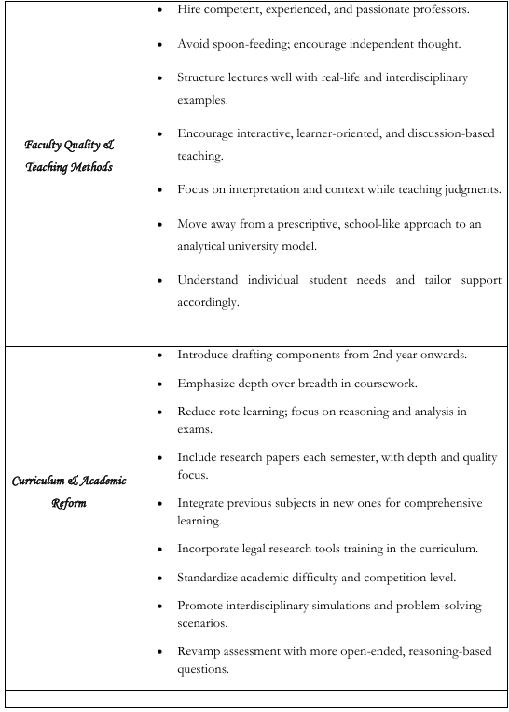
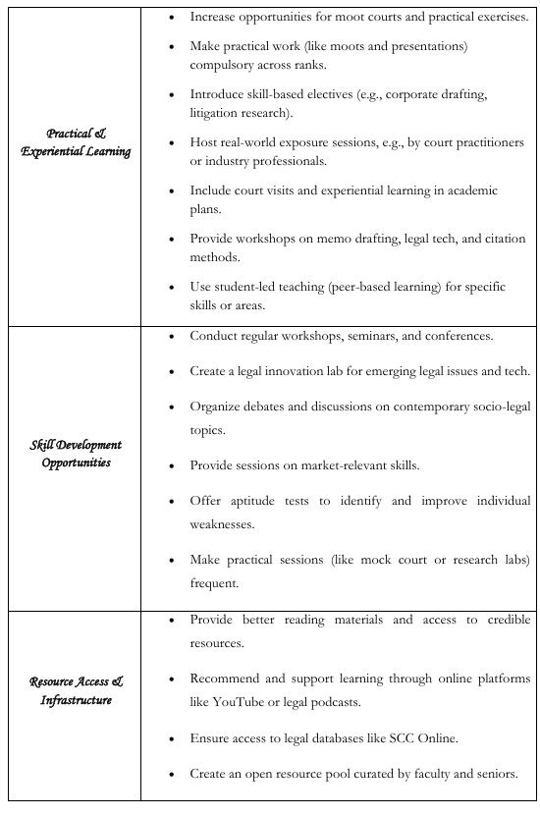
- Some Unique Suggestions from the Students
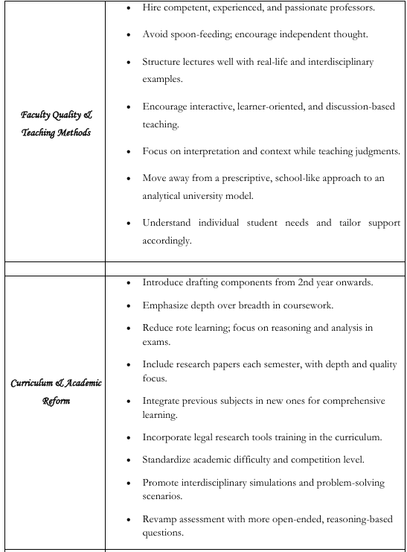
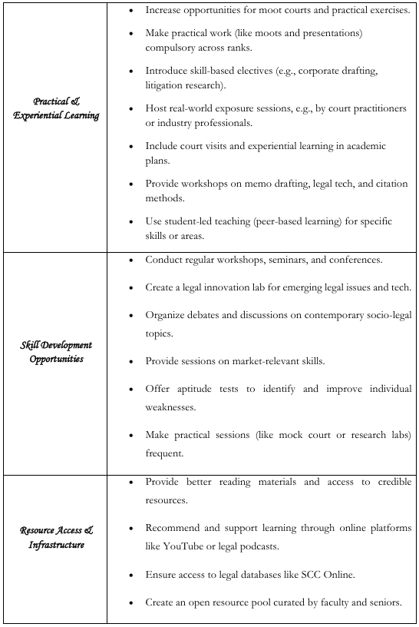
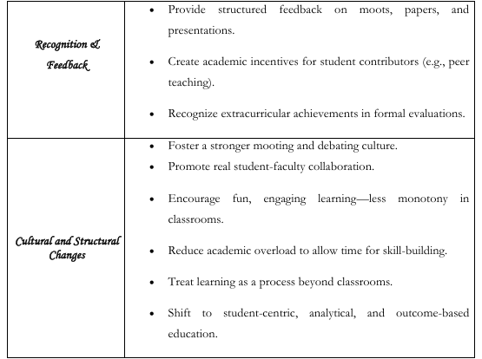
- Changes Recommended
Drawing from the responses and insights shared by students at NLU, Nagpur, it is evident that while foundational exposure to analytical, cognitive, and technical skills exists within the current academic framework, there remains considerable scope for deepening and systematizing this development. The following recommendations aim to bridge the identified skill gaps, enhance student engagement, and foster a more holistic legal education environment.
Curriculum Design And Pedagogical Reforms
- Integrating Skill-Based Components from Early Years
The current curriculum should progressively embed skill-centric exercises from the second year onwards. Modules focusing on judgment analysis, precedent application, and doctrinal interpretation can be introduced through a mix of coursework and assessment-based assignments. This will provide students with continuous exposure to real-world legal reasoning and reduce the overemphasis on theoretical learning in early semesters.
- Revamping Assessment Methods Traditional assessment models often prioritize rote memorization and reward the replication of legal texts. To nurture deeper analytical thinking, assessments should incorporate open-ended, reasoning-based questions, case studies, and hypothetical problem-solving exercises. Such reforms will allow students to demonstrate not just what they know, but how they apply legal concepts in diverse scenarios.
- Embedding Legal Technology Training
As technical skills gain increasing relevance in modern legal practice, the curriculum must include structured modules on legal research databases (e.g., SCC Online, Manupatra), use of Boolean logic, formatting legal documents using citation manuals (e.g., Bluebook), and productivity tools such as Excel. These practical components should not be treated as peripheral workshops but as integrated, credit-bearing academic activities.
- Encouraging Adaptive Thinking and Argumentative Agility
The ability to reframe arguments mid-conversation or to defend legal positions under pressure is crucial in litigation and advocacy. Incorporating oral drills, mock viva-style evaluations, and structured Socratic questioning in regular classroom sessions can help students develop intellectual flexibility and persuasive communication.
Practical and Experiential Learning Opportunities
- Formalizing Moot Courts and Practical Exercises
Moot Court participation and Client-Counselling simulations should be embedded into the curriculum as compulsory credit-earning components. Their inclusion across academic years will ensure every student engages meaningfully with real-life legal application and not just theoretical case law.
- Establishing Legal Skill Clinics
Institutions should consider setting up student-led legal clinics—focused on research, drafting, or technology—under faculty mentorship. These labs can serve as platforms for experiential learning and also foster collaborative problem-solving around current legal challenges.
- Enhancing Industry Interface
Exposure to the professional world through regular guest lectures by practicing lawyers, court visits, and internship-linked workshops can help contextualize classroom learning. Such engagements will bridge the gap between legal academia and the dynamic demands of practice.
Faculty Development And Teaching Innovations
- Encouraging Pedagogical Training and Innovation
Faculty members should be supported and incentivized to adopt interactive, student centric teaching methodologies. Training workshops in modern legal education strategies—such as flipped classrooms, problem-based learning, and narrative case walkthroughs—can enrich the teaching-learning process.
- Moving Away from Lecture Monotony Relying solely on extended lectures often hinders student engagement. Instead, combining lecture segments with case-based discussions, small group activities, and reflective tasks will encourage students to take ownership of their learning and apply concepts critically.
- Prioritizing Contextual and Interdisciplinary Teaching
Law does not operate in isolation. Teachers should emphasize the socio-legal, political, and economic context in which legal doctrines evolve. This approach will not only deepen understanding but also allow students to draw interdisciplinary connections, a skill highly valued in both academia and practice.
Infrastructure And Access To Learning Resources
- Expanding Access to Legal Databases and Tools
Ensuring seamless access to premium research databases such as SCC Online, HeinOnline, and JSTOR is essential. Alongside access, students should be given structured training in the effective use of these platforms.
- Creating Open-Access Academic Repositories
Institutions can support the creation of curated, open-access reading banks, annotated templates, model research papers, and faculty-reviewed guides. These shared resources foster peer-based learning and standardize quality benchmarks.
- Blending Formal and Informal Learning Platforms
Acknowledging the growing role of online education, institutions should officially recommend high-quality educational YouTube channels, legal podcasts, and digital lectures as supplementary tools. By legitimizing informal learning, students are empowered to take initiative and diversify their methods of engagement.
Peer Learning and Personal Skill Development
- Facilitating Peer Mentorship and Teaching
Structured peer teaching initiatives, especially across batches, can strengthen foundational understanding and confidence. Senior students conducting sessions on research strategy, oral argumentation, or legal writing can significantly supplement classroom learning.
- Encouraging Reflective and Self-Directed Learning Students should be guided to engage in periodic self-assessment, goal setting, and learning through experimentation. Opportunities for reflection can be built into project submissions or end-of-semester portfolios.
- Recognizing Personal Growth and Innovation
Beyond academics, institutions should acknowledge students’ effort in personal skill building, be it time management, resilience, or critical thinking. Awards, formal mentions, or leadership opportunities for such traits can cultivate a growth-oriented academic culture.

- Conclusion
The survey findings clearly highlight that students demonstrate a reasonable grasp of foundational legal skills while also facing moderate challenges in tasks that require deeper synthesis and application of knowledge. The data reveal that in the realm of analytical skills, students are generally comfortable with tasks such as comparing legal doctrines and identifying logical gaps in judicial decisions. They are adept at using structured methodologies to analyze case materials. However, the survey demonstrates that tasks like applying precedents to different factual matrices, though fundamental, remain challenging. These results suggest that while students are exposed to legal texts and case studies, they benefit less from exercises that require innovative problem-solving under novel conditions. These observations call for a more experiential learning approach that immerses students in simulated real-life scenarios. Likewise, the cognitive skills section indicates that students possess strong recall capabilities and adaptive argumentation skills. The ease with which students re-adapt their arguments in spontaneous settings reflects classroom practices such as mock trials and debates. Yet, significant challenges remain when it comes to tasks that require prolonged focus and multitasking. The highest scores in this category signal the need for improved strategies to build sustained concentration and efficient information processing, skills that are crucial for legal research and practice. In the technical skills domain, our survey documents modest proficiency in practical tasks such as formatting legal memos and executing Boolean searches on legal databases. Students show confidence in applying predefined formats and generating simple Excel formulas. Nonetheless, drafting legally sound agreements and interpreting dense doctrinal texts expose gaps in their technical expertise. The moderately elevated difficulty ratings for these tasks indicate that while the students can follow structured procedures, there is a pressing need to further integrate technical training with substantive legal knowledge. The survey also sheds light on the factors contributing to skill development, which include academic rigor, participation in moot court competitions, and co-curricular activities. Personal growth factors such as peer learning, self-study, and mentorship play substantial roles in enhancing both cognitive and technical capabilities.
In light of these findings, the report recommends several targeted interventions. First, integrating skill-based components from the early years of study is imperative. Second, assessment methods should shift from rote learning towards problem-solving and open-ended analysis. Third, the curriculum must embed legal technology training and facilitate practical learning opportunities through moot courts, legal clinics, and industry exposure. Finally, regular, formative feedback coupled with peer mentorship can further enhance these
essential skills.
References –
- Ministry of Education, Government of India. (2020). National Education Policy 2020. Retrieved from https://www.education.gov.in/sites/upload_files/mhrd/files/NEP_Final_English_0.pdf.
- Bhat, S., & Gireesh, G. (2020, October 30). Legal education and National Education Policy 2020. Centre for Research in Public Policy. Retrieved from https://ceerapub.nls.ac.in/legal-education-and-national-education-policy-2020/.
- Advocates Act, 1961, § 7(1)(h).
- Bar Council of India. (2008). Rules on Standards of Legal Education, 2008.
- Basheer, S., & Mukherjee, S. (2010). Regulating Indian legal education: Some thoughts for reform. SSRN Electronic Journal. https://doi.org/10.2139/ssrn.1584037.
- National Center for Improvement of Educational Assessment. (n.d.). Analytical thinking as a 21st century skill. Retrieved from https://nciea.org/blog/analytical-thinking-as-a-21st-century-skill/.
- Sander, J. (2011). Cognitive skills. In S. Goldstein & J. A. Naglieri (Eds.), Encyclopedia of child behavior and development (pp. 382). Springer. https://doi.org/10.1007/978-0-387-79061-9_609.
- Ahn, B., Cox, M. F., London, J., & Zhu, J. (2013). Investigating the attributes and expectations of engineering Ph.Ds working in industry.

